EMP/01

The class has following data: Employee ID, Employee Name, Date of Birth, Salary of the employee and supervisior ID

EMP/02

Add overloaded constructors to initialize the objects with details. Employee Id, Employee Name, Date of Birth are manadatory attributes to create an employee.

EMP/03

Write functions to update employee details with attributes (Salary, supervisorID).

EMP/04

Write a function GetSupervisorReportees() to show the employee details under one supervisor.

EMP/05

Write DisplayDetails() to display employee attributes in a formatted way as below.  
 Name:<name>  
 EmplD: <Employee ID>  
 DOB: <Date of Birth>  
 Salary: <Salary>  
 SupervisorID: <supervisor ID>

EMP/06

Write a function to copy a given Employee Object and return a new one.

EMP/07

Write a function operator() to receive an ID and check if given ID is the supervisor ID of this object.

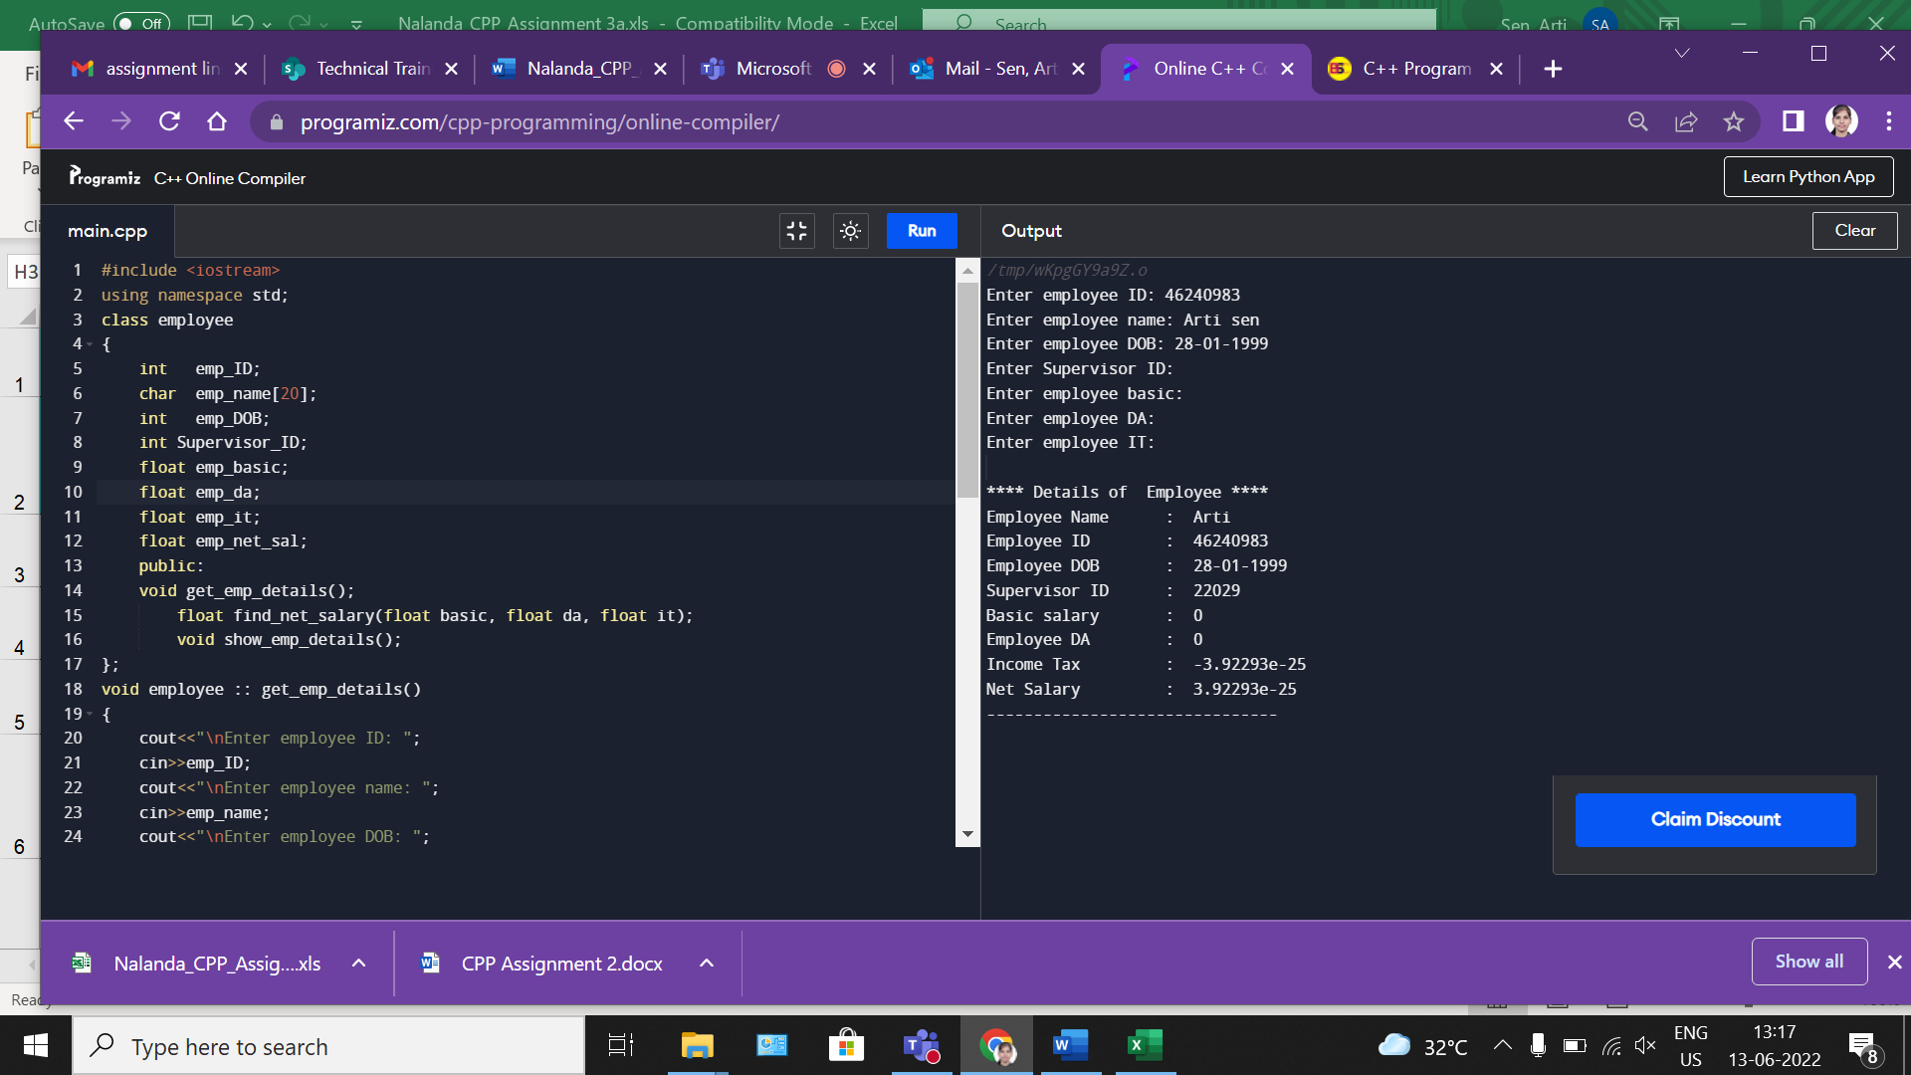

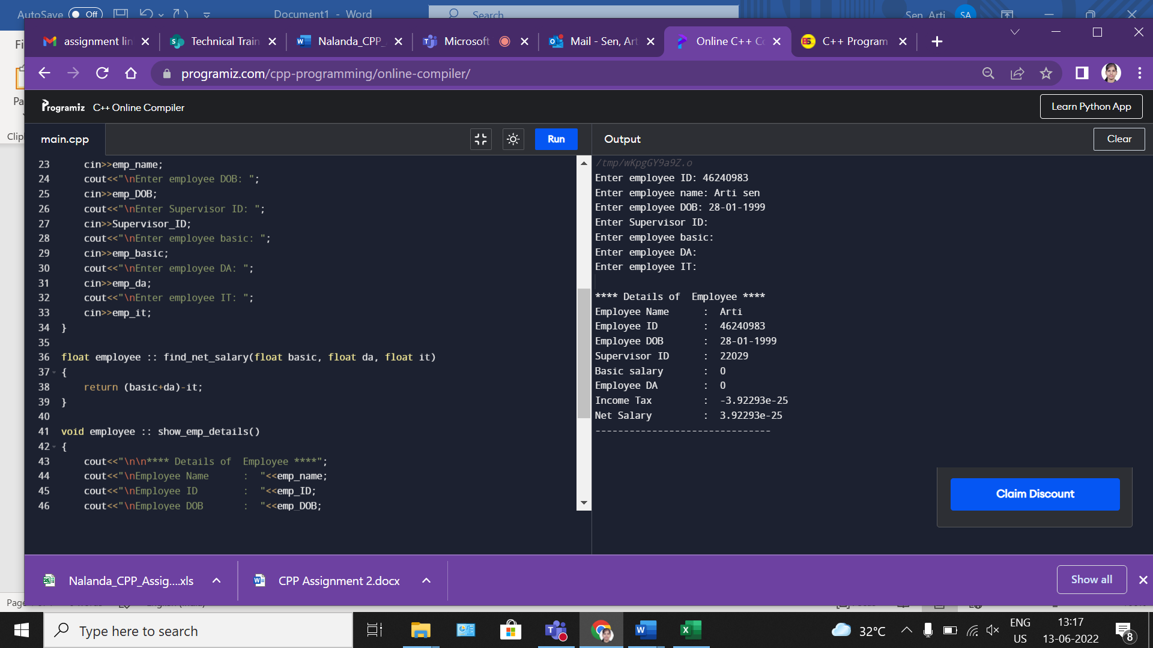

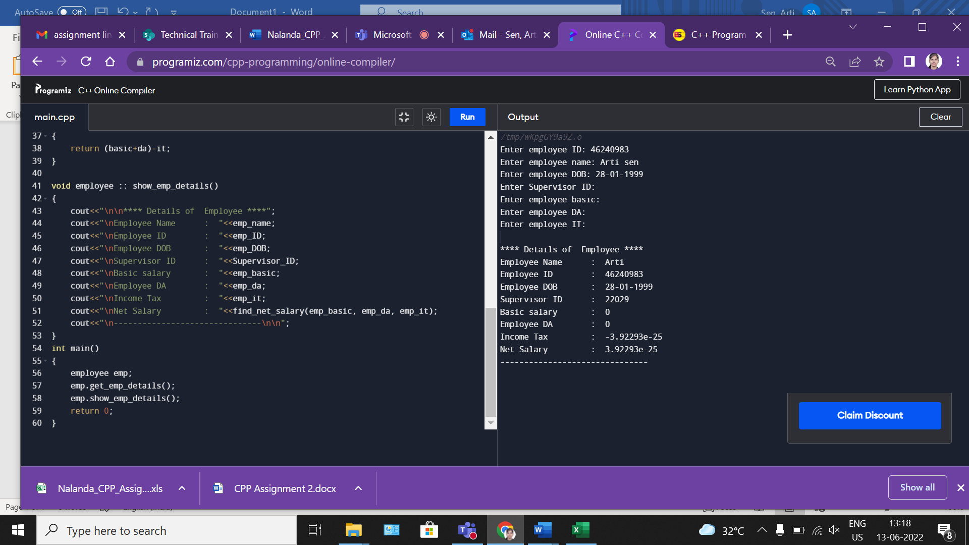

#include <iostream>

using namespace std;

class employee

{

int emp_ID;

char emp_name[20];

int emp_DOB;

int Supervisor_ID;

float emp_basic;

float emp_da;

float emp_it;

float emp_net_sal;

public:

void get_emp_details();

float find_net_salary(float basic, float da, float it);

void show_emp_details();

};

void employee :: get_emp_details()

{

cout<<"\nEnter employee ID: ";

cin>>emp_ID;

cout<<"\nEnter employee name: ";

cin>>emp_name;

cout<<"\nEnter employee DOB: ";

cin>>emp_DOB;

cout<<"\nEnter Supervisor ID: ";

cin>>Supervisor_ID;

cout<<"\nEnter employee basic: ";

cin>>emp_basic;

cout<<"\nEnter employee DA: ";

cin>>emp_da;

cout<<"\nEnter employee IT: ";

cin>>emp_it;

}

float employee :: find_net_salary(float basic, float da, float it)

{

return (basic+da)-it;

}

void employee :: show_emp_details()

{

cout<<"\n\n**** Details of Employee ****";

cout<<"\nEmployee Name : "<<emp_name;

cout<<"\nEmployee ID : "<<emp_ID;

cout<<"\nEmployee DOB : "<<emp_DOB;

cout<<"\nSupervisor ID : "<<Supervisor_ID;

cout<<"\nBasic salary : "<<emp_basic;

cout<<"\nEmployee DA : "<<emp_da;

cout<<"\nIncome Tax : "<<emp_it;

cout<<"\nNet Salary : "<<find_net_salary(emp_basic, emp_da, emp_it);

cout<<"\n-------------------------------\n\n";

}

int main()

{

employee emp;

emp.get_emp_details();

emp.show_emp_details();

return 0;

}